THE TEMPLATE FOR THE ABSTRACT SUBMISSION TO EASTMAG-2022

F.A. FirstAuthor¹, S.A. SecondAuthor² and P.A. PresentingAuthor^{1*}
¹Department of Material Science, SUNY, New York, USA
²Institute Laue-Langevin, Grenoble, France
*e-mail: CorrespondingAuthor@email

All abstracts should be submitted in MS Word (*.doc, *.docx) format via the Abstract Submission Form only, available on the personal account no later than April 25, 2022. Abstracts sent via email, fax, or regular mail will not be processed or acknowledged. NO confirmation letter will be sent after submission – every participant is able to see, open, change and delete all uploaded files in personal account. Please, feel free to update submitted by you file any time prior to the deadline (April 25, 2022).
All abstracts must be written in English. The abstract should fit on A4 size (210×297 mm) paper, single-sided with top, bottom, left and right margins of 25 mm. The abstract must not exceed two pages including text, figures, tables, acknowledgements, references etc. Times New Roman 12 pt size font, justified with single line spacing is the preferred text format. Use formatting of paragraphs and page layout of this template.
The text should begin with the title written in capital letters, and next line should be empty. The authors (initials or first names before surnames) are indicated in the next lines, and each followed by a footnote digit (1, 2, 3 ...) referring to the affiliation and the respective address. The presenting author's name should be underlined. Mark the corresponding author with an asterisk (*). On the next lines the affiliation, city, and country, which are preceded by a footnote digit referring to the respective author name(s) should be indicated; each organization is written in new line. If authors are affiliated in more than one organization, each affiliation should be indicated by ^{1,2} etc. The corresponding author’s email address is indicated in next line. All these lines should be centered.
Then one line should be left empty. Main text preferably should not be parted into the sections. First line of each paragraph begins at 1 cm from the margin.
All figures (*.pdf, *.eps, *.ps, *.tiff, *.jpg, *.jpeg, *.png formats, refer with: Fig. 1, Fig. 2, ...) should be presented as part of the text, leaving enough space so that the caption will not be confused with the text, and must be upload as separate files. Image resolution must be at least 300 dpi.

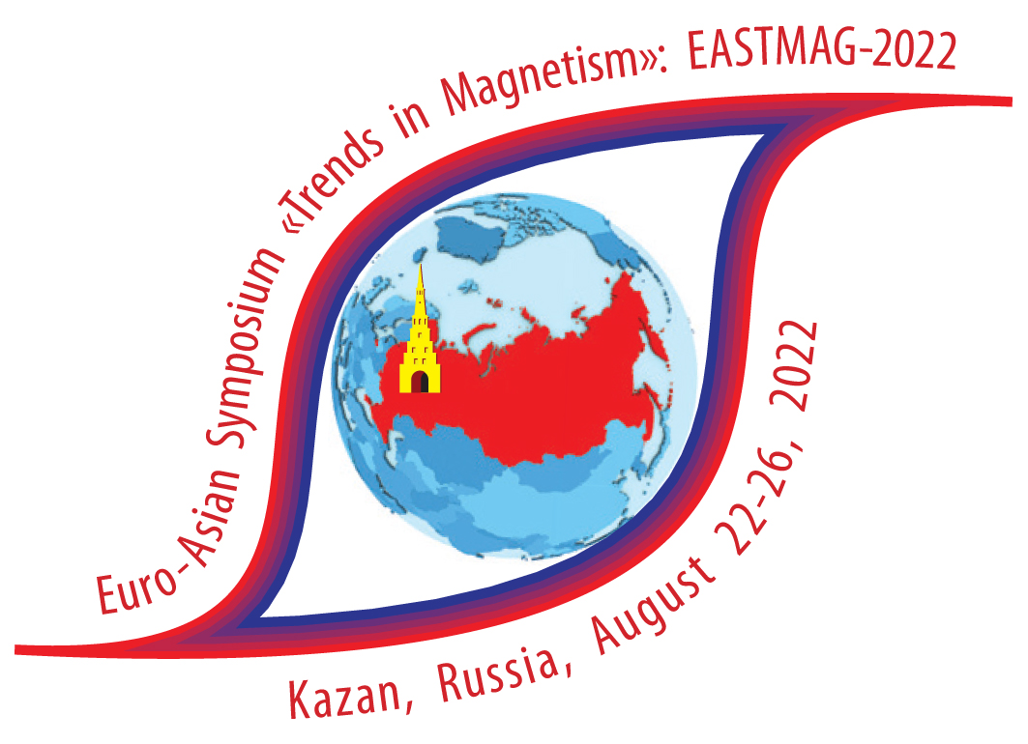
Fig. 1. Times New Roman font 11 pt with single line spacing is preferred figure captions format.

Tables (refer with: Table 1, Table 2, ...) should be presented as part of the text, but in such a way as to avoid confusion with the text.
Table 1. Type of sizes

Items of text | Size | Appearance
Title | 12 pt | Capital, centered
Author’s name | 12 pt | Plain, centered
Affiliation | 12 pt | Plain, centered
Main text | 12 pt | Plain, each paragraph begins at 1 cm from the margin
Figure, table captions | 11 pt | Plain, centered
References | 11 pt | Plain, begins from the margin

References are cited in the text just by square brackets [1] sequentially in order of first appearance. Two or more references at a time may be put in one set of brackets [1, 2]. See our examples: Fig.1, Table 1, [1–3].
If you have any questions regarding preparation or submission of your abstract please do not hesitate to email us at eastmag2022@kfti.knc.ru, eastmag2022@mail.ru
Support by RSF (IEEE, ARC, ARCNN, DFG, NSF etc.) is acknowledged.

1. S.V. Vonsovskii, Magnetism, Nauka, Moscow, (1971) [in Russian].
2. F. Bolzoni and M. F. Pirini, J. Appl. Phys. 68, 2315–2323 (1990).
3. V. Sechovsky and L. Havela, in K.H.J. Buschow (ed.), Handbook of Magnetic Materials, vol. 11, Elsevier Science B.V., Amsterdam, p. 1, (1998).

